

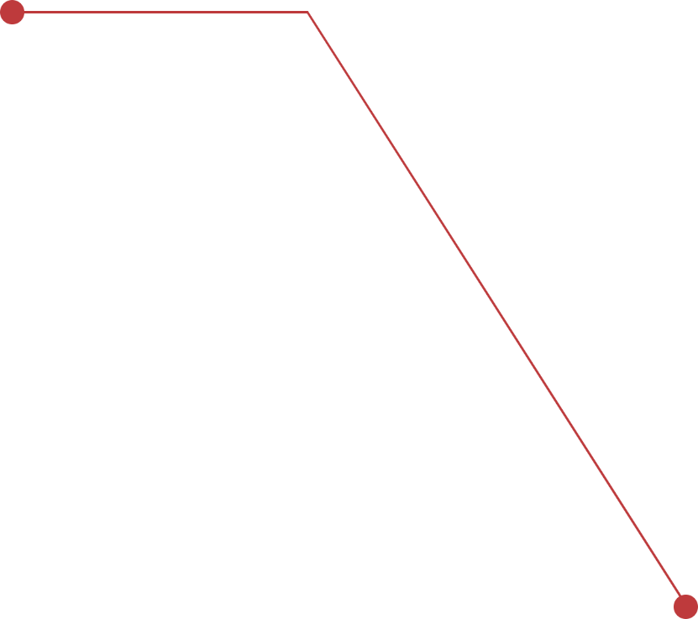  
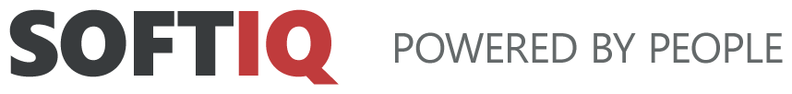Digital transformation of the City of Reykjavik for the Education and Welfare departments.

An app dedicated to parents who want to enroll their children in an education entity, and an app for people with disabilities who can book interviews and consultations.

Industry: **Public Sector**Technologies: **WebMethods, React + Cypress, Azure, SQL, React**

Client: **SOFTIQ & Imperio for the City of Reykjavik**

The City of Reykjavik functions in Iceland on the same basis as the ministry in Poland. It manages issues such as security, education, assistance, job opportunities, transportation, culture and many other social aspects important to residents. It is a portal that collects sensitive and important information about its citizens.

**What was the business need?**

The City of Reykjavík often uses outsourced teams for public and government projects, in order to supplement the skills of specialists in their in house teams. SOFTIQ, in cooperation with Imperio, took part in the development side of the projects.

Within the "SFS - Education" area, the app is dedicated to parents who want to enroll their children in school. Until now, it was done "manually", on paper. The application aims to streamline this process through electronic enrollment.

Within the "VEL -Welfare" area, an app is being developed aimed at people with disabilities, who can select a date through the app and apply for consultations with officials.

**What was the challenge?**

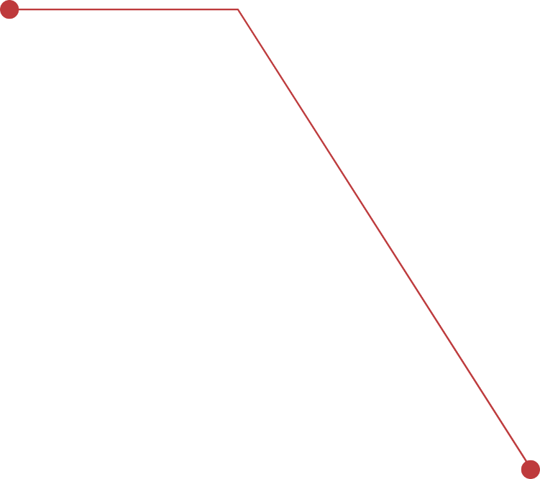 Along with the process of digitalizing the City of Reykjavik, a new IT department has been created. Projects are managed using Agile methodology and the Scrum framework. Together with the existing Icelandic team, learning side by side, we are building a strong collaborative framework to overcome any potential challenge.



**How did we do it?**

The goal of the project is to provide user-oriented services and reduce paper usage when submitting applications. The system has been designed with full integration possibilities allowing it to be combined with other services.

It aims to make services more accessible to individuals by making it easier for them to submit applications, book counseling calls, and then assign them to the most appropriate consultant to address each person's individual needs. The main goal is a streamlined registration of requests and applications and a more efficient flow of information about the services provided. The goal of the project is to provide user-oriented services and reduce paper usage when submitting applications. The system has been designed with full integration possibilities allowing it to be combined with other services.

It aims to make services more accessible to individuals by making it easier for them to submit applications, book counseling calls, and then assign them to the most appropriate consultant to address each person's individual needs. The main goal is a streamlined registration of requests and applications and a more efficient flow of information about the services provided.

**Project process and workflow:**

In the projects for the City of Reykjavík, we used the SCRUM methodology. Most of the design, content and information materials were provided by the client, and through in-depth workshops and brainstorming sessions we were able to develop a proper workflow and properly implement all functionalities.

**What were the benefits for the client?**

Better access for citizens to services and information

Better working environment for City of Reykjavik employees and consultants

Reduced paper usage

A system that integrates with many other systems in one place

Efficiency and increased speed of application submission

Moving the system online

Fewer manual tasks

Greater access to data

Improved monitoring for improvements

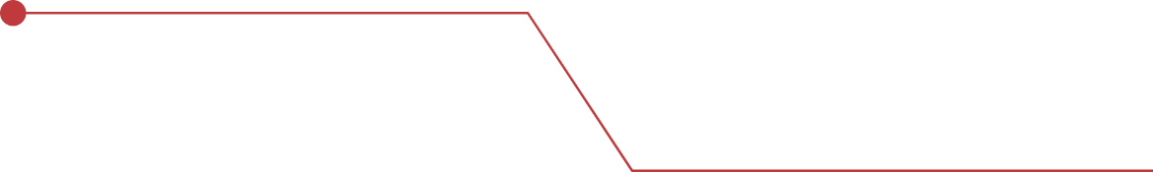Less complicated application system